1. (a) Construct a Huffman tree (variable-length encoding) for the following [10 points]:

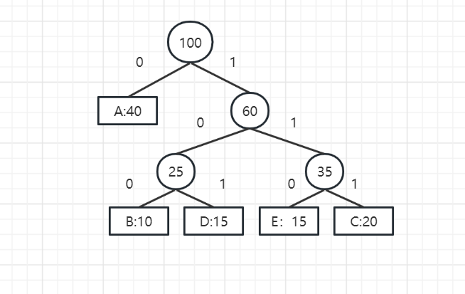

(b) Encode ABACABAD using the tree you generated for (a). [5 points]

0 100 0 111 0 100 0 101

(c) Decode 100010111001010 using the tree you generated for (a). [5 points]

BADEADA

(d) What compression gain (percentage of improvement) do we get by using Huffman encoding (variable-length encoding) instead of a fixed-length encoding scheme? Draw the tree for the fixed-length encoding. [5+10=15 points]

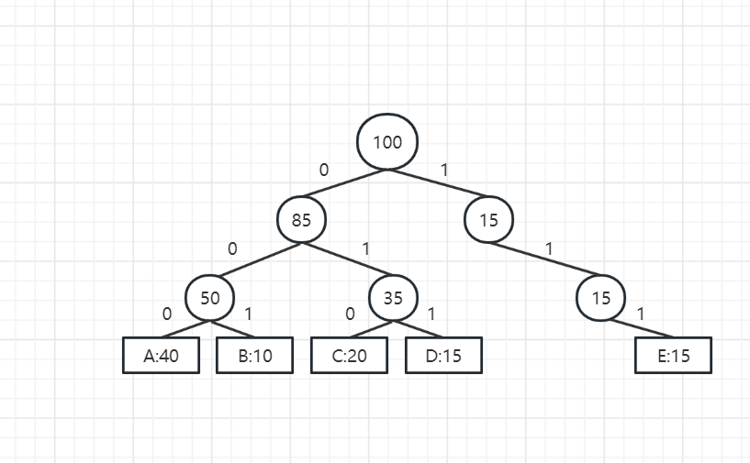

With fixed-length codes, 3 bits for each character=300,000 bits

Variable-length codes need (40*1+60*3)*1000 = 240,000 bits,20% savings

2. Use Dijkstra’s algorithm to find the shortest path between vertices A and F. (Start at A,

end at F). Show all the steps of your work. [15 points]

|  |  |  |  |  |  |  |
| --- | --- | --- | --- | --- | --- | --- |
| A | B | C | D | E | F | G |
| 0 | ∞ | ∞ | ∞ | ∞ | ∞ | ∞ |
|  | 1 | 3 |  |  | 10 |  |
|  |  | 2 | 8 | 6 | 10 | 3 |
|  |  |  | 8 | 5 | 10 | 3 |
|  |  |  | 8 | 5 | 10 |  |
|  |  |  | 7 |  | 7 |  |
|  |  |  | 7 |  |  |  |

The shortest path between A and F is : A-B-C-E-F